Project Design Phase- II

Data Flow Diagram & User Stories

|  |  |
| --- | --- |
| Date | 10 October 2022 |
| Team ID | PNT2022TMID22484 |
| Project Name | Industry-Specific Intelligent Fire Management  System |

**Data Flow Diagram:**

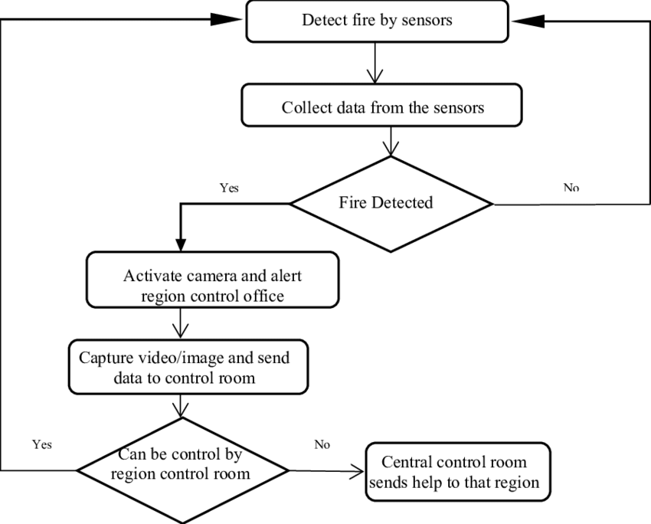

**User Stories**

|  |  |  |  |  |  |  |
| --- | --- | --- | --- | --- | --- | --- |
| **User Type** | **Functional requirement** | **User story**  **number** | **User story/task** | **Acceptance criteria** | **Priority** | **Release** |
| Customer | Registration | USN-1 | As a user, I | I can access | High | Sprint-1 |
| (care |  |  | can register | my account/ |  |  |
| executive, |  |  | for the | dashboard |  |  |
| Administrator) |  |  | application |  |  |  |
|  |  |  | by entering |  |  |  |
|  |  |  | my mail, |  |  |  |
|  |  |  | password, |  |  |  |
|  |  |  | and |  |  |  |
|  |  |  | confirming |  |  |  |
|  |  |  | my |  |  |  |
|  |  |  | password |  |  |  |
|  |  | USN-2 | As a user, I | I can receive | High | Sprint-1 |
|  | will receive | confirmation |  |  |
|  | confirmation | email & click |  |  |
|  | email once I | confirm |  |  |
|  | have |  |  |  |
|  | registered |  |  |  |
|  | for the |  |  |  |
|  | application |  |  |  |
|  | Dashboard | USN-3 | As a user, I | I can register | LOW | Sprint-2 |
|  |  | can register | & access the |  |  |
|  |  | for the | dashboard |  |  |
|  |  | application | with Internet |  |  |
|  |  | through | login |  |  |
|  |  | internet |  |  |  |
|  |  | USN-4 | As a user, I | I can confirm | Medium | Sprint-1 |
|  | can register | the |  |  |
|  | for the | registration in |  |  |
|  | application | Gmail |  |  |
|  | through |  |  |  |
|  | Gmail |  |  |  |
|  |  |  |  |  |  |  |
|  |  |  |  |  |  |  |
|  |  |  |  |  |  |  |
|  |  |  |  |  |  |  |
|  |  |  |  |  |  |  |
|  | Login | USN-5 | As a user, I | I can login | High | Sprint-1 |
|  |  | can log into | with my id |  |  |
|  |  | the | and password |  |  |
|  |  | application |  |  |  |
|  |  | by entering |  |  |  |
|  |  | email & |  |  |  |
|  |  | password |  |  |  |